To set Git credentials

$ git config --global -e

$ git config --global -l

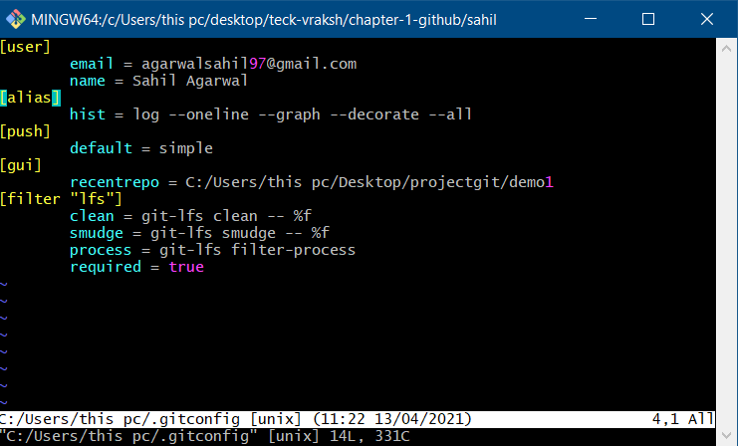

To clone a repo

$Git Clone ‘repo.git’

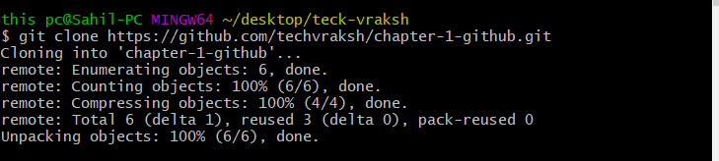

To initialize a Repository

**$git init**

Git States with Local:

**Working Directory** : all files present in above “demo” folder

**Staging Area** : file preparing for commit, first store in staging area, then only we can commit

**Repository/Commit History** : committed with version or save changes to git repo

$git to add files to the staging area before they are commited

**$git add .**

To add all the untracked files

**$git add filename**

to add a particular file

**$git commit -m “first commit” filename**

To commit the changes

To check all version of file, every commit they provide commit id

**# git log test.txt**

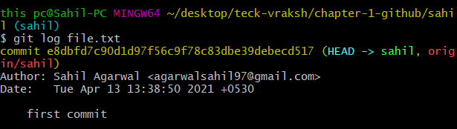

See details of log

**# git show commitID**

